Design and develop a colorful hospital management dashboard using HTML and CSS that displays doctor and patient statistics, emergency alerts, appointment information, and an animated graph showing patient flow. The dashboard should be visually attractive, responsive, and easy to use.
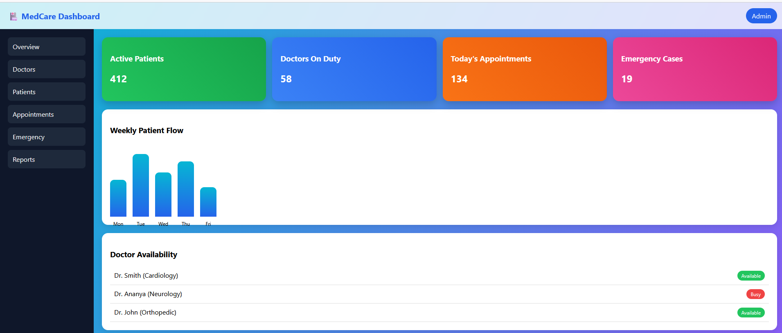
Design and develop a lamp lighting animation using HTML and CSS that simulates a glowing light effect. The design should be visually attractive and use CSS keyframe animations to create smooth lighting transitions without using JavaScript.

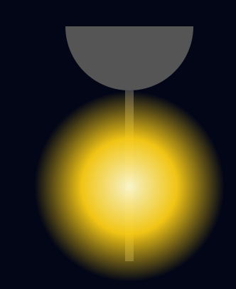

Design and develop a colorful and interactive student/employee profile dashboard using HTML and CSS that includes a profile card with photo, attendance progress, weekly timetable, achievement badges, notifications, and visually appealing shadow and hover effects. The dashboard should be responsive, modern, and user-friendly.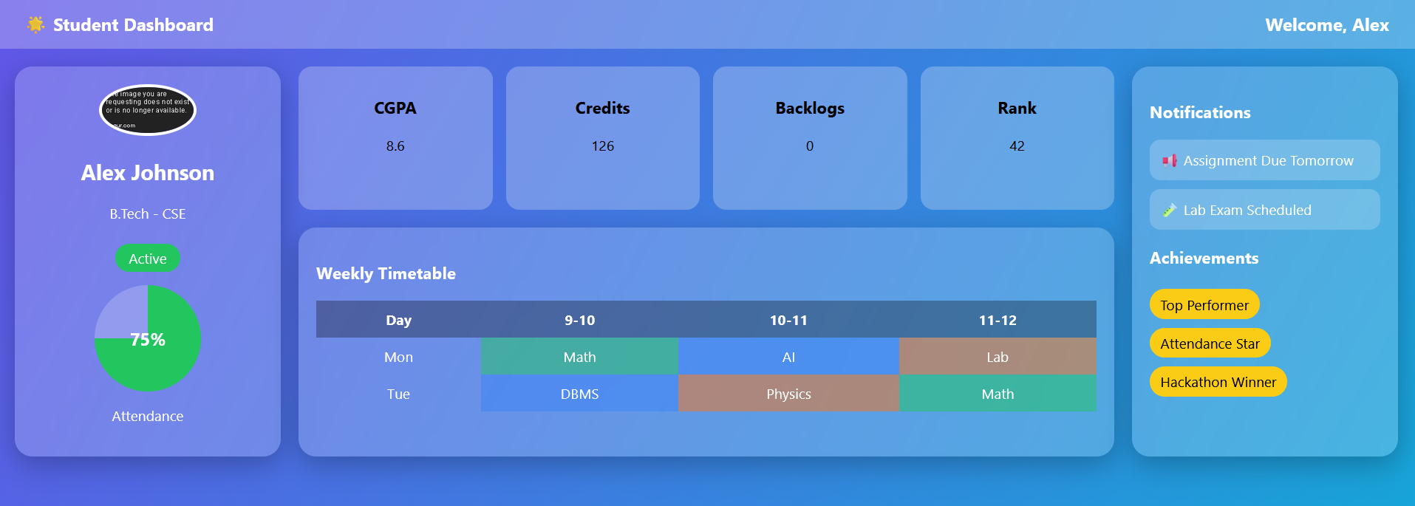

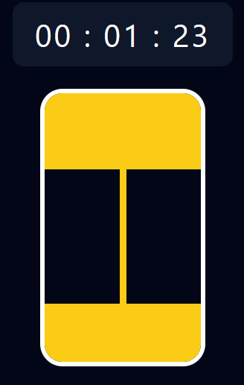
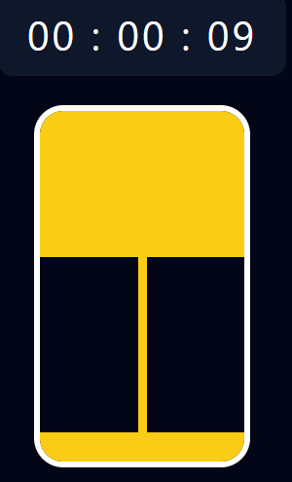
Design and develop an animated hourglass (sand timer) using HTML, CSS, and JavaScript that visually represents the flow of sand while displaying real-time second, minute, and hour counters. The animation should be smooth, synchronized with the timer, and user-friendly.

Design and develop a colorful Share Market dashboard using only HTML and CSS that displays stock cards with gain/loss indicators, a visually appealing bar or line chart representing stock trends, market news, and top gainers. The layout should be responsive, fully styled with colors, shadows, and hover effects, and the chart should be created purely with CSS.
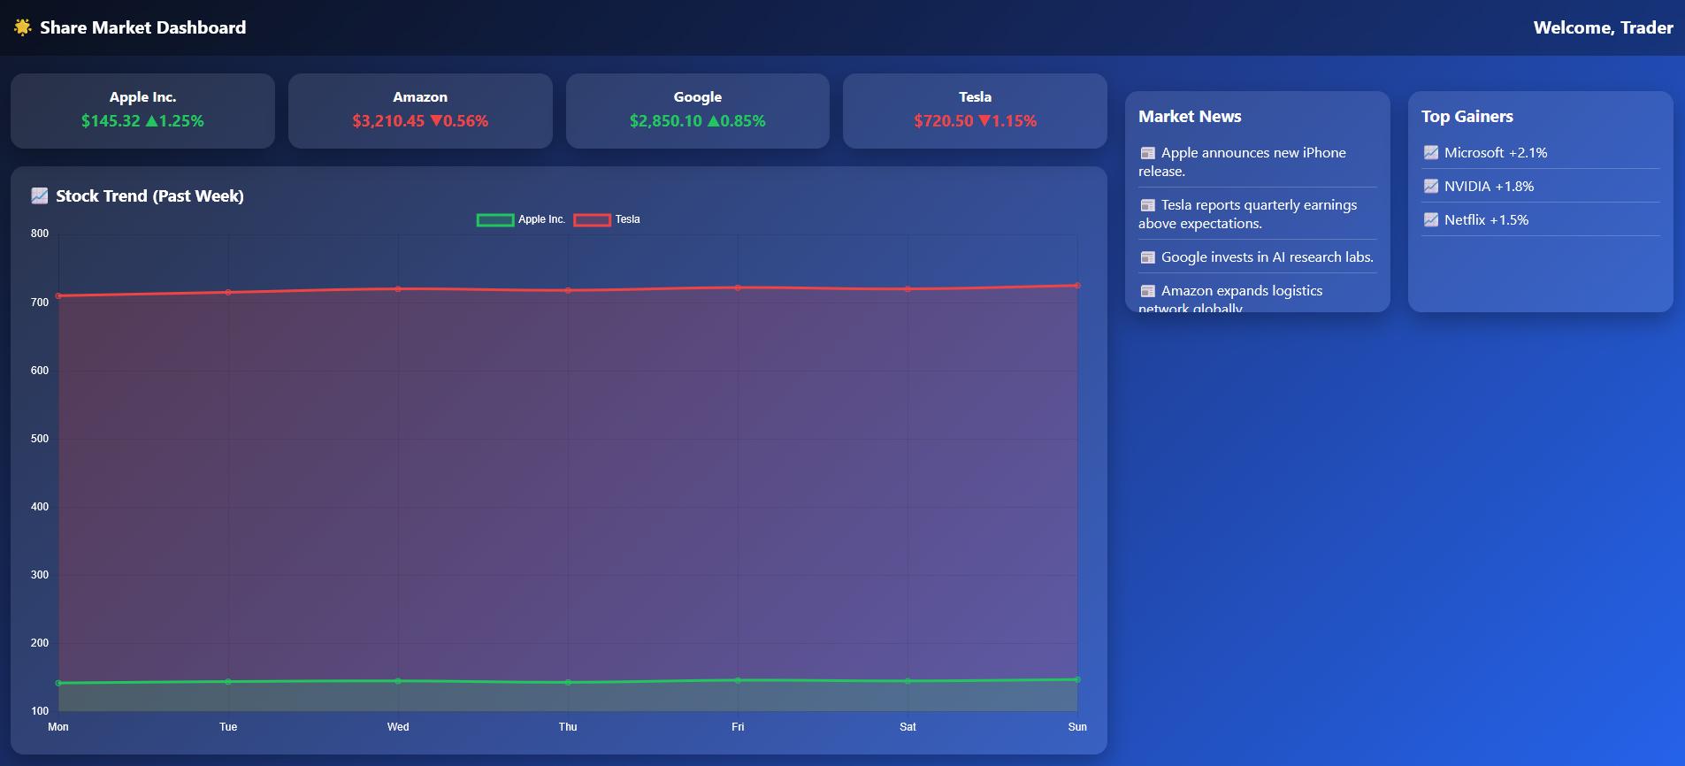
Design and develop an animated smiley face using HTML and CSS whose mouth changes gradually and the expression between happy and sad. The animation should loop infinitely, be smooth, visually appealing, and created entirely with HTML and CSS without using JavaScript.

